Machine Learning vs Business Analytics

1. Introduction

In today’s data-driven world, organizations rely heavily on data to gain insights, optimize operations, and predict future trends. Two key disciplines that enable such data utilization are Machine Learning (ML) and Business Analytics (BA).
Although both work with data, they serve different purposes and use different methodologies. This document explains what Machine Learning is, explores the fundamentals of Business Analytics, and clearly distinguishes between the two.

2. Machine Learning

2.1 Definition

Machine Learning (ML) is a branch of Artificial Intelligence (AI) that focuses on building algorithms capable of learning from and making predictions based on data. Instead of relying on explicit programming instructions, ML systems identify patterns in historical data and use these patterns to make predictions, classifications, or decisions when exposed to new data.

2.2 How It Works

Machine Learning involves the following key steps:
- Data Collection: Gathering raw data from various sources such as databases, sensors, websites, or applications.
- Data Preparation: Cleaning and transforming the data into a suitable format for analysis.
- Model Training: Feeding data into algorithms to allow the system to learn underlying patterns.
- Model Evaluation: Testing the model’s accuracy and performance using unseen data.
- Prediction/Deployment: Using the trained model to make real-world predictions or automate decision-making.

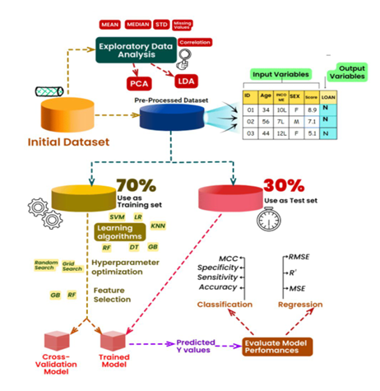

2.3 Types of Machine Learning

Machine Learning can be classified into three main types:

Supervised Learning:
- The algorithm is trained on labeled data (i.e., data with known outcomes).
Example: Predicting house prices based on features like size, location, and number of rooms.

Unsupervised Learning:

The algorithm identifies patterns or groupings in unlabeled data.
Example: Customer segmentation in marketing.

Reinforcement Learning:

The model learns by interacting with an environment and receiving rewards or penalties based on its actions.

Example: Self-driving cars learning to navigate roads safely.

2.4 Applications of Machine Learning
- Fraud detection in banking
- Predictive maintenance in manufacturing
- Image and speech recognition
- Personalized product recommendations
- Medical diagnosis and drug discovery

3. Business Analytics

3.1 Definition

Business Analytics (BA) refers to the systematic process of exploring, analyzing, and interpreting data to derive meaningful insights that support decision-making. It focuses on using data to understand business performance, identify trends, and recommend strategies for improvement.

3.2 How It Works

Business Analytics typically follows these stages:
- Data Collection and Management: Gathering business-related data from internal and external sources.
- Data Analysis: Using statistical methods and visualization tools to interpret the data.
- Reporting and Visualization: Presenting findings through dashboards and reports for decision-makers.
- Decision-Making: Applying insights to improve business outcomes.

3.3 Types of Business Analytics
- Descriptive Analytics: Analyzes historical data to understand what has happened.
Example: Monthly sales reports.
- Diagnostic Analytics: Examines data to understand why something happened.
Example: Determining the cause of declining profits.
- Predictive Analytics: Uses statistical models and ML techniques to predict future outcomes.

Example: Forecasting next quarter’s revenue.
- Prescriptive Analytics: Recommends actions to achieve desired business goals.
Example: Suggesting optimal pricing strategies.

3.4 Applications of Business Analytics
- Performance dashboards and KPI tracking
- Market trend analysis
- Customer behavior insights
- Supply chain optimization
- Financial risk management

4. Key Differences Between Machine Learning and Business Analytics

Although both ML and BA deal with data, their purpose, approach, and outcomes are distinct.
Aspect | Machine Learning (ML) | Business Analytics (BA)
Primary Goal | Automate predictions and decisions using data patterns. | Derive insights and support strategic decisions using data analysis.
Focus Area | Prediction and automation. | Understanding and optimization.
Data Requirements | Works best with large and complex datasets. | Can operate on smaller, structured datasets.
Techniques Used | Algorithms (Neural Networks, Decision Trees, SVM, etc.) | Statistical methods, visualization, and trend analysis.
Output | Predictive model or automated decision system. | Reports, dashboards, and analytical insights.
Tools and Technologies | Python, R, TensorFlow, Scikit-learn, Keras. | Excel, SQL, Tableau, Power BI, SAS.
Human Involvement | Minimal once automated; systems learn and adapt. | High — requires interpretation and decision-making by analysts.
Analysis Type | Predictive and prescriptive. | Descriptive and diagnostic.

5. Relationship Between Machine Learning and Business Analytics

Machine Learning and Business Analytics are complementary disciplines rather than competing ones.
- Business Analytics helps organizations understand historical data and identify areas for improvement.
- Machine Learning takes it a step further by predicting future outcomes and automating decisions based on patterns in the data.

In modern enterprises, the integration of both disciplines leads to data-driven intelligence — where analytics explains why things happen, and machine learning predicts what will happen next.

6. Real-World Example

Consider a retail company aiming to increase sales:

Business Analytics:
- Analysts use sales data to understand which products performed well, which regions underperformed, and why sales dropped in certain months.

Machine Learning:
- A predictive model analyzes customer behavior data and forecasts which products a customer is likely to purchase next month, enabling personalized recommendations and targeted marketing.

Together, these approaches enable smarter business strategies and competitive advantage.

7. Conclusion

Machine Learning and Business Analytics are two pillars of modern data science.
While Business Analytics provides the foundation for understanding the past and present, Machine Learning empowers organizations to predict and shape the future through automation and pattern recognition.
By combining both, businesses can move from data-driven decision-making to intelligent, self-improving systems that continuously optimize performance.

